# docker build -t rails-ruby .

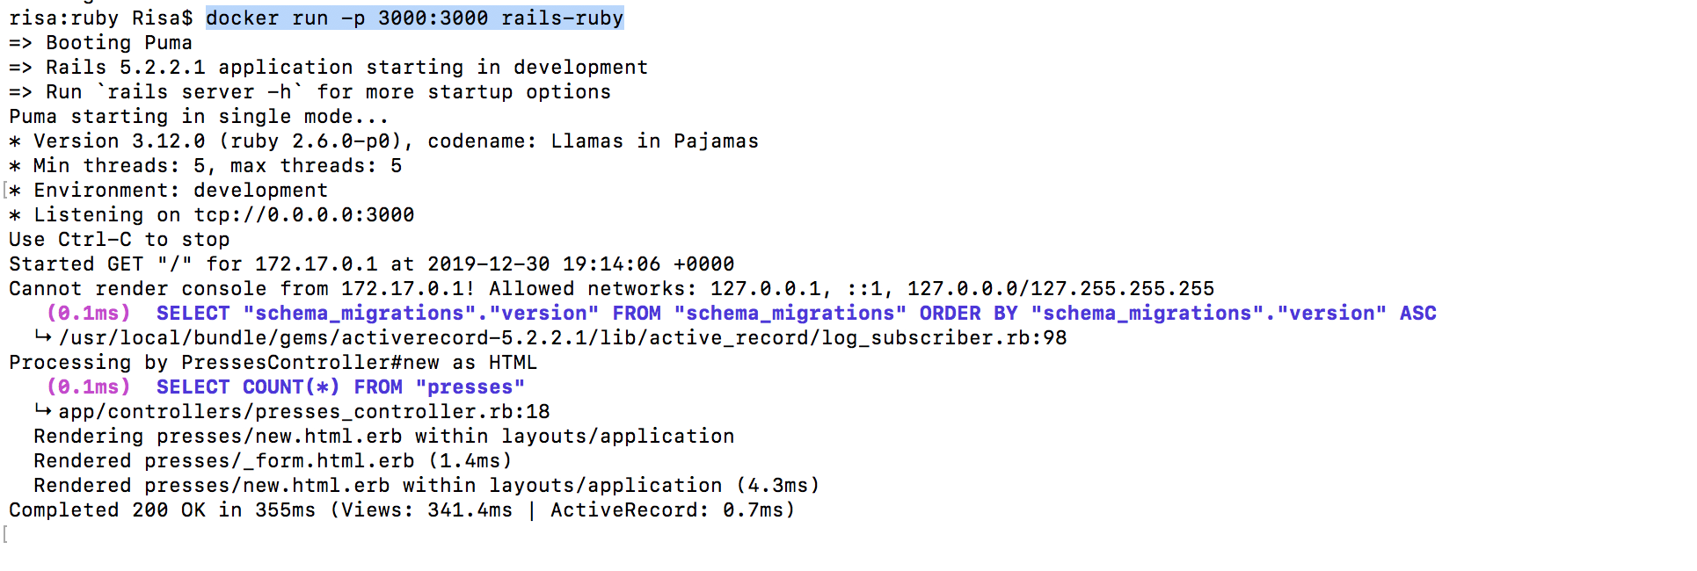# docker run -p 3000:3000 rails-ruby

